LOCATION : NATIONWIDE
DATE : 18.08.2017
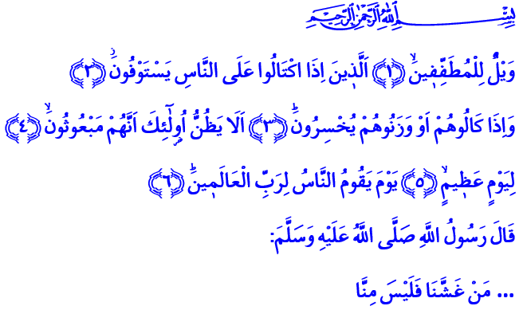
ETHICS OF TRADE AND COMMERCE
Honorable Brothers and Sisters!
Our Prophet (pbuh) occasionally visited the bazaar of Medina. He observed the people who traded and dealt with each other and talked with them. He warned those who behaved wrong or had a wrong attitude. Indeed, our Lord Almighty sent these verses which contains vital warnings regarding trade: “Woe unto those who give short measure: those who, when they are to receive their due from (other) people, demand that it be given in full –but when they have to measure or weigh whatever they owe to others, give less than what is due! Do they not know that they are bound to be raised from the dead (and called to account) on an awesome Day –the Day when all men shall stand before the Sustainer of all the worlds?”
Brothers and Sisters!
After these verses were revealed, the believers began to be more careful and precise when conducting trade under the guidance of our Prophet. Our Master, Allah’s Messenger (pbuh) was very pleased with this. He encouraged them to conduct trade with this prayer: “O Lord! Give your blessings to the scales, measurements and trade of these people!”
Honorable Believers!
Islam taught us a trade ethic, a commercial ethic. Being and behaving honest while refraining from lying and deceiving is at the heart of this ethic. Because honesty and righteousness are required of a believer. They are a must if we are to live our lives as a virtuous individual. Moreover, a believer should wear the cloak of truthfulness in every aspect of his life, not just in trade. The verse of our Lord Almighty, 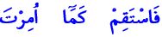 “Therefore stand firm (in the straight path) as thou art commended” is the anchor point of a believer’s words, actions and attitude. Our Prophet’s (pbuh) warning, 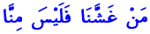 “Whoever cheats us is not one of us” is an essential principle in a believer’s relationship with other people.
Dear Brothers and Sisters!
The Messenger of Allah (pbuh) said: “The trustworthy, honest Muslim merchant will be with the Prophets, the honest men, and martyrs on the Day of Resurrection.” As this hadith states, being honest and open in trade and commerce is an important principle. This is one of the most beautiful example of it: One of his companions came to our Prophet (pbuh) to ask about certain issues that bothered him regarding trade. The Messenger of Allah listened him carefully and advised him: “When you want to buy something, state the price you want. And when you want to sell something, state its value in the market, not higher.”
Esteemed Brothers and Sisters!
Our Prophet (pbuh) warned us in this hadith: “It is not permissible for a Muslim to sell his brother goods in which there is a defect, without pointing that out to him.” Because hiding the defect of a good destroys the divine blessing in trade as well as the trust between people. Even though the seller seems like making a profit, his only profit will be disappointment. Knowing this, a believer couldn’t see all the ways leading to profit and gain as fair. He wouldn’t resort to ways like deceitful advertising, cheating, unfair competition and exorbitant profit. He wouldn’t profit from the loss of others. He’d know deceiving others is actually deceiving himself. Indeed, Lord Almighty informs us about the destruction of communities in the past because they did not conduct trade honestly and spread corruption on earth.
Brothers and Sisters!
One of the main principles of trade ethics is to take care that the profit from trade is halal. A believer who believes that he is certainly going to account for his actions would not mix haram in his income. In this context, it is not permissible for a Muslim to trade the things our Lord Almighty forbids. A Muslim must refrain from trading alcohol and drugs, gambling or tax evasion.
Beloved Believers!
As painful as it is, some lose their sentiment on halal income day by day. Some could act as if everything is fair, driven only by profit and their interests. Some could be a slave to greed, avarice, earning more without rules; in short, a slave to earthly goods. Some even carelessly and immodestly exploit the material and spiritual gains of the greatest sign of Allah, the humans.
Like in every other aspect of our lives, what really matters in trade is the approval of our Lord Almighty. So come! Let us build our income on righteousness and truthfulness. Let us respect the rightful due of others and make our tables and our lives plentiful. Let us be careful to ensure no ill-gotten food comes into our house. Let this hadith of our Prophet (pbuh) be a standard for us in trade and commerce: “This property is like a sweet fresh fruit; whoever takes it without greediness, he is blessed in it, and whoever takes it with greediness, he is not blessed in it.”

Al-Mutaffifin, 83/1-6.
Ibn Majah, The Chapters on Business Transactions, 35.
Al-Bukhari, Sales and Trade, 53.
Al-Hud, 11/112.
Müslim, Faith, 164.
Tirmizî, The Book on Business, 4.
Ibn Majah, The Chapters on Business Transactions, 29.
Ibn Majah, The Chapters on Business Transactions, 45.
Al-Hud, 11/84-95.
Al-Bukhari, Obligatory Charity Tax, 50. Written by: General Directorate of Religious Services

